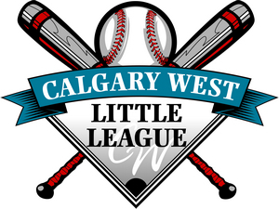
Calgary West Little League
Umpire Registration 2023

Name
Full Address
(incl postal code)
Phone |  | Cell
Email
Current Division |  | Age

Have you previously umpired? | Yes |  | No
Have you attended any Umpire training courses? | Yes |  | No
If Yes, list course(s) and date(s) attended

If you answered Yes to previously umpired, place an X by all that apply
Major Plate |  | Major Base
Minor Plate |  | Minor Base
Rookie Plate |  | Rookie Base

List CWLL Umpire equipment/shirt/hat that you already have and if it fits.

Please save the file to your desktop and e-mail completed form to uic@cwll.org

